MySQL Assignment – 01

Q 1. Display Databases
Login to MySQL and write a query to display all databases already present in the system.
Ans:
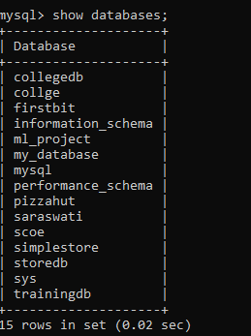
Q2. Create countries Table
Write an SQL query to create a table named countries including columns country_id,
country_name and region_id.
After this display the structure of table.
Ans:
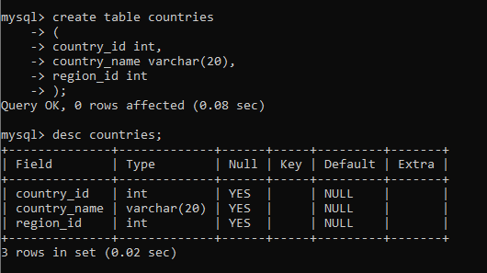

Q3. Create jobs Table with Constraints
Write an SQL query to create a table named jobs including columns job_id, job_title,
min_salary, max_salary.
Apply constraints:
- job_id must be Primary Key
- job_title cannot be NULL
- max_salary must not exceed 25000
Ans:
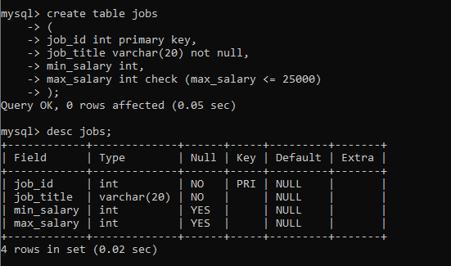
Q4. Create job_history Table
Write an SQL query to create a table named job_history including columns employee_id,
start_date, end_date, job_id and department_id.
Ans:
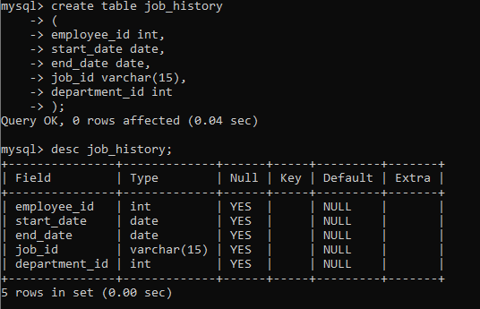
Q5. Add UNIQUE Constraint
Alter the countries table so that duplicate values in country_id are not allowed during insertion.
Ans:
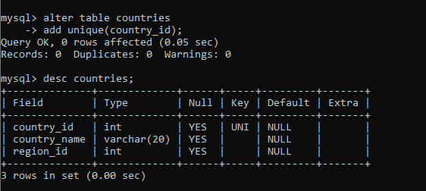
Q6. Create jobs_default Table with DEFAULT Values
Write an SQL query to create a table named jobs_default including columns job_id, job_title,
min_salary and max_salary.
Set default values:
- job_title default should be blank (“”)
- min_salary default should be 8000
- max_salary default should be NULL
Ans:
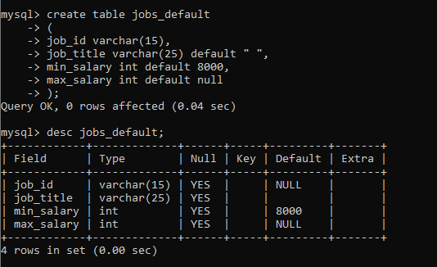
Q 7. Create departments Table (Composite Primary Key)
Create Department table with following structure:
Field Name Type Null Key
department_id DECIMAL(4,0) NO PRI
department_name VARCHAR(30) NO
manager_id DECIMAL(6,0) NO PRI
location_id DECIMAL(4,0) YES
Composite Primary Key: (department_id, manager_id)
Ans:
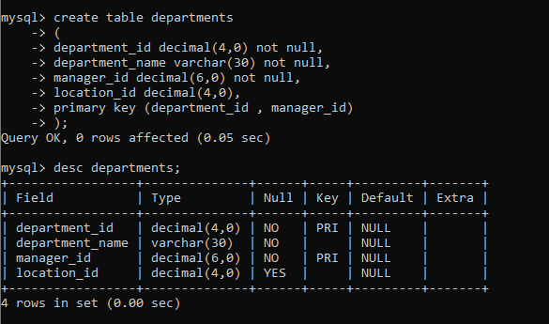

Q8. Create employees Table with Normal Foreign Key
Write an SQL query to create a table named employees including columns:
employee_id, first_name, last_name, email, phone_number, hire_date, job_id,
salary, commission, manager_id and department_id.
Column Name Data Type
employee_id INT
first_name VARCHAR(50)
last_name VARCHAR(50)
email VARCHAR(100)
phone_number VARCHAR(20)
hire_date DATE
job_id INT
salary DECIMAL(10,2)
commission DECIMAL(10,2)
manager_id INT
department_id INT
Apply constraints:
- employee_id must be Primary Key
- department_id must be a Foreign Key referencing departments(department_id)
Ans:
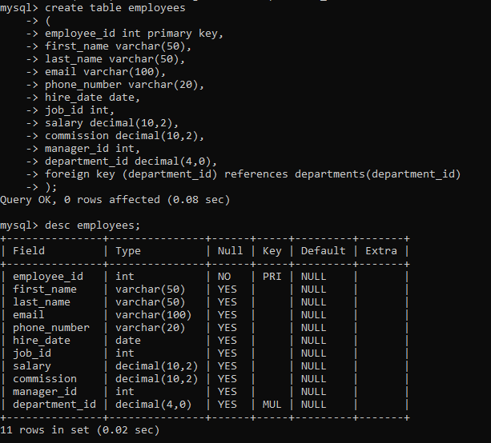
Q 9). Composite Foreign Key Implementation
Step 1: Create department_managers Table
Create a table named department_managers with following structure:
Field Name Data Type Null Key
department_id DECIMAL(4,0) NO PRI
manager_id DECIMAL(6,0) NO PRI
manager_name VARCHAR(50) NO
Composite Primary Key: (department_id, manager_id)
Step 2: Apply Composite Foreign Key in employees Table
Alter the employees table so that the combination (department_id, manager_id)
must exist in department_managers(department_id, manager_id).
Ans:
